wing.modfield=aov(**Length.mm**~Locality, data=quickiefield)

summary(wing.modfield)

Df Sum Sq Mean Sq F value Pr(>F)

Locality 6 3.250 0.5416 17.75 <2e-16 ***

Residuals 234 7.142 0.0305

---

Signif. codes: 0 ‘***’ 0.001 ‘**’ 0.01 ‘*’ 0.05 ‘.’ 0.1 ‘ ’ 1

print(HSD.test(wing.modfield, 'Locality'))

$means

Length.mm std r Min Max

APR 2.972106 0.18150143 50 2.7161 3.3794

ARS 2.923912 0.19623178 17 2.4947 3.2727

RMO 3.020627 0.17820906 45 2.5603 3.2766

RPV 2.952185 0.17732182 47 2.5153 3.2980

SJU 3.499600 0.09896948 11 3.3735 3.6804

TLC 3.087050 0.16956123 54 2.6372 3.4295

TPN 3.038935 0.16698587 17 2.4860 3.1923

$groups

trt means M

1 SJU 3.499600 a

2 TLC 3.087050 b

3 TPN 3.038935 bc

4 RMO 3.020627 bc

5 APR 2.972106 c

6 RPV 2.952185 c

7 ARS 2.923912 c

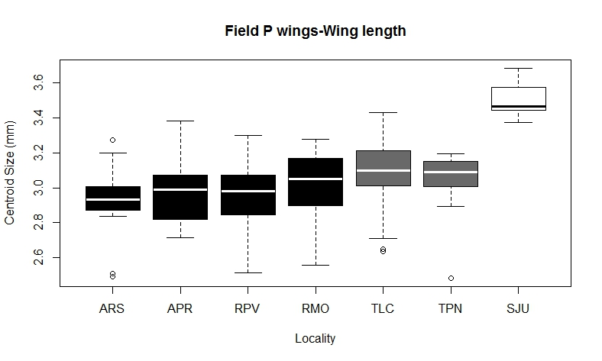

bc

bc

b

a

cc

c

c

wing.modfield1=aov(**X13.CS.scaled**~Locality, data=quickiefield)

> summary(wing.modfield1)

Df Sum Sq Mean Sq F value Pr(>F)

Locality 6 3.482 0.5803 17.89 <2e-16 ***

Residuals 234 7.590 0.0324

---

Signif. codes: 0 ‘***’ 0.001 ‘**’ 0.01 ‘*’ 0.05 ‘.’ 0.1 ‘ ’ 1

print(HSD.test(wing.modfield1, 'Locality'))

$means

X13.CS.scaled std r Min Max

APR 3.148284 0.1907268 50 2.835301 3.591093

ARS 3.098635 0.2052213 17 2.636715 3.493591

RMO 3.206301 0.1896142 45 2.697692 3.522093

RPV 3.131318 0.1779141 47 2.692136 3.449526

SJU 3.696278 0.1022116 11 3.580779 3.870497

TLC 3.268289 0.1710420 54 2.793631 3.635400

TPN 3.225488 0.1659016 17 2.697011 3.388531

$groups

trt means M

1 SJU 3.696278 a

2 TLC 3.268289 b

3 TPN 3.225488 bc

4 RMO 3.206301 bc

5 APR 3.148284 c

6 RPV 3.131318 c

7 ARS 3.098635 c

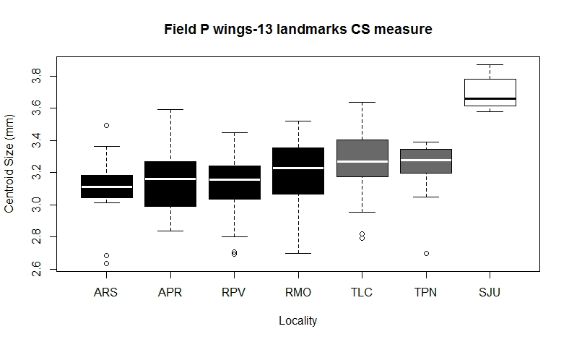

bc

b

bc

c

c

c

a

wing.modfield2=aov(**X18.CS.scaled**~Locality, data=quickiefield)

> summary(wing.modfield2)

Df Sum Sq Mean Sq F value Pr(>F)

Locality 6 3.056 0.5093 19.49 <2e-16 ***

Residuals 234 6.115 0.0261

---

Signif. codes: 0 ‘***’ 0.001 ‘**’ 0.01 ‘*’ 0.05 ‘.’ 0.1 ‘ ’ 1

print(HSD.test(wing.modfield2, 'Locality'))

$means

X18.CS.scaled std r Min Max

APR 2.753536 0.1781440 50 2.457657 3.226904

ARS 2.702679 0.1761075 17 2.292060 3.059314

RMO 2.827038 0.1718331 45 2.376443 3.104821

RPV 2.745573 0.1586501 47 2.364029 3.079863

SJU 3.259513 0.1053271 11 3.119065 3.445587

TLC 2.869694 0.1475185 54 2.433972 3.191393

TPN 2.888652 0.1463544 17 2.460630 3.105671

$groups

trt means M

1 SJU 3.259513 a

2 TPN 2.888652 b

3 TLC 2.869694 b

4 RMO 2.827038 bc

5 APR 2.753536 c

6 RPV 2.745573 c

7 ARS 2.702679 c

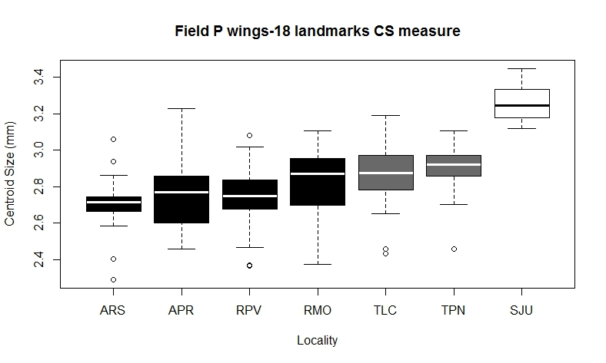

b

bc

c

c

c

b

a